**Student Name: Weight: 25%**

**Student ID:**

# Project: Classes

# Type: Individual and Group Assignment

* Students should **ONLY USE** programming constructs covered in the course material.
* **Submissions using programming concepts that are not covered in the course material will be penalized.**
* **Penalty with no limit could be applied**
* **Late submissions will not be accepted**

## Scenario

Jojo’s Hair Salon needs a system to track customer appointments. Jojo has hired your team to create an appointment management system which is customized to her salon’s business needs.

## Equipment and Materials

For this assignment, you will need:

* Python IDE
* Git software
* GitHub repository

## Instructions

This assignment consists of two parts, both completed outside of class time. See the course schedule and Brightspace for exact dates. Rubrics are available in Brightspace.

**Part 1: Project Submission – Group Assignment NO submission**

1. Create the Appointment class as outlined in the document and verify its correct operation by running the test program provided. Each student is encouraged to individually complete Part 1 though there will be no submissions for Part 1.
2. Test that your appointment class generates the output as shown below when you run test_appointment.py

Sample run of test_appointment.py

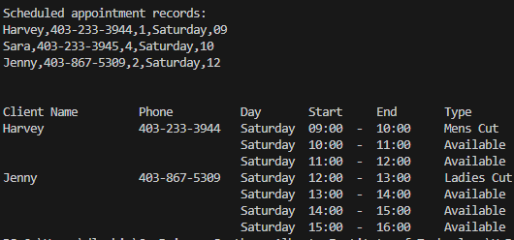

### Part 1 – Appointment Class (Individual Assignment)

**Properties/Attributes** (hidden)

client_name, client_phone, appt_type, day_of_week, start_time_hour

**Methods**

|  |  |
| --- | --- |
| **Method Name** | **Description** |
| Constructor | * __init__() initializes the Appointment object properties. * The constructor should assign empty/zero for the first three properties (i.e. representing an available appointment) and accept two parameters for assigning to day_of_week and start_time_hour |
| Getters | * Implement one getter method for each Appointment property. The getter method should return the value of the property |
| get_appt_type_desc() | * An additional “getter” method that translates and returns the object’s appt_type as a text description, I.e.:   **appt_type description**  0 Available  1 Mens Cut  2 Ladies Cut  3 Mens Colouring  4 Ladies Colouring |
| get_end_time_hour() | * An additional “getter” method that returns the value of the object’s start_time_hour + 1 |
| Setters | * Implement a setter method for the first three Appointment properties: client_name, client_phone, and appt_type. The setter method should set the property to the parameter value received |
| schedule() | * Sets client_name. client_phone, and appt_type properties to the parameter values received |
| cancel() | * Resets client_name. client_phone, and appt_type properties to empty/zero |
| format_record() | * Returns a string representation of an Appointment object * This representation should include all appointment properties separated by a comma * Same format as in “appointments.csv” file, e.g.:   Harvey,403-233-3944,1,Saturday,09 |
| __str__() | * Returns a string representation of an Appointment object * This representation is formatted for display, e.g.:   Harvey 403-233-3944 Saturday 09:00 - 10:00 Mens Cut |

**Part 2: Project Submission – Group Assignment**

1. Have one member of your group set up a GitHub repository for Part 2 of this project. Make sure that this GitHub repository is **private**. Add group members and your instructor as collaborators. **Add daveleskiw as a collaborator so that your instructor can mark your assignment.**
2. Create a separate branch in GitHub for each group member, containing the part they will work on. The branch name should include the task name and the student name.
3. Develop the code for the Appointment Management Module as specified in this document. As a team, you will also need to assess each member’s Appointment class and then finalize one version for your group’s solution.
4. GitHub must be effectively used for group collaboration.
5. Ensure all group members update their parts to their respective GitHub branches.
6. The final project code must be pushed to master/main on GitHub.
7. Check your solution against the detailed marking criteria available in Brightspace.
8. Create a project video.

Each group will submit a **video** to Brightspace or their GitHub Repository (either as a URL or an uploaded video file). In the video:

* + EACH team member will introduce themselves – camera should be on. Please use laptop camera/screen share to create video (not a phone). **You can start a team meeting in MS Teams, share the appropriate screen and record the video. After you can download the video to your local machine and submit it via brightspace.**
  + Provide a demonstration of the application covering all the functionality CORRESPONDING TO THE SAMPLE RUN PROVIDED.
  + Share the **group’s final solution** (Python code) on screen and have EACH team member explain a **portion of the code** that they developed. A debugger may be used to step through sections of code (optional).

1. Submit the following files to Brightspace:

* A link to your group’s GitHub project repository
* The GitHub project repository should include:
  + - The code of the program that you implemented (.py files).
    - A copy of your sample runs (.txt files) that correspond to the sample runs provided.
    - All data files updated by program after the test runs have been completed.
    - Video presentation.

## Appointment Management System Details

Jojo’s Hair Salon requires that the appointment management system track the following information for each appointment:

* Client name
* Client phone number
* Type of appointment:
  1. Available
  2. Mens cut $50
  3. Ladies cut $80
  4. Mens Colouring $50
  5. Ladies Colouring $120
* Day of week: Monday, Tuesday, Wednesday, Thursday, Friday, Saturday
* Start time of appointment (e.g. 9 AM)

Note: all appointments are one hour long.

The appointment management system needs to provide the following functionality:

* create a one-week calendar of available appointments for Monday - Saturday, 9 AM – 4 PM daily (last appointment is 4-5 PM)
* allow the user to optionally load previously booked appointments into the week’s calendar
* allow the user to select and perform any of the following menu functions (continuously until the user chooses to exit the system):
  + Schedule an appointment
  + Find appointment by name
  + Print calendar for a specific day
  + Cancel an appointment
  + Exit the system
* allow the user to optionally save all scheduled appointments to a file

A senior software developer has already done some design work on the *Appointment* class as well as the core functions required for the appointment management module. Please refer to the detailed information in the following two sections as you complete both programming parts of this project.

**Recommended Data Structure**

The appl_cal is a list that hold references to appointment objects as outline below:

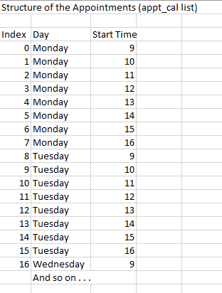

So appl_cal[10] holds the appointment information for Tuesday starting at 11 AM. Code to create the appt_cal list is provided in create_weekly_calendar().

### Part 2 - Appointment Management Module (Group Assignment)

Create a **separate module** (.py file)for your appointment management application code which will be comprised of various functions, including a *main()* entry function that controls the overall processing. The functions listed below are required but you may use additional functions too.

|  |  |
| --- | --- |
| **Function Name** | **Description** |
| create_weekly_calendar() In appointmentSkel.py | * Iterates through each day of the week (Monday to Saturday) * For each day, iterates through each available hour (9 to 16) * For each hour, creates new Appointment object and adds it to the appointment list (i.e. calendar) * *** PROVIDED *** |
| load_scheduled_appointments()  In apptFile.py | * Inputs appointment filename from user * Iterates over each line (i.e. appointment) in the file, parsing the attribute values into separate variables * Calls find_appointment_by_time() to locate the corresponding appointment in the list and invoke the schedule() method to set the properties appropriately * Returns the number of scheduled appointments loaded |
| schedule_appointment  In apptMgmt.py | * inputs the day and start time * locates the appropriate time slot * inputs the client data and type of appointment * update the appropriate time slot to capture the appointment |
| print_menu() In AppointmentSkel.py | * Displays the menu of application options * Accepts menu selection from user until valid selection is entered * Returns user’s **valid** selection *** PROVIDED *** |
| find_appointment_by_time() In apptMgmt.py | * Receives the day and start hour of the appointment to find * Searches the list of Appointments for corresponding day and start hour * If the appointment is found, returns the Appointment object, otherwise returns nothing |
| show_appointments_by_name() In apptReports.py | * Receives the client name of the appointment(s) to show * Searches the list of Appointments for corresponding client name, allowing for partial & non-case sensitive matches * Displays all matching appointments in the format given in the Sample Run (hint: use the __str__() method implicitly) |
| show_appointments_by_day() In apptReports.py | * Receives the day of the appointments to show * Searches the list of Appointments for the corresponding day * Displays all matching appointments in the format given in the Sample Run (hint: use the __str__() method implicitly) |
| save_scheduled_appointments() In ApptFile.py | * Inputs appointment filename from user, checks if the file already exists and if so, allows user to proceed (i.e. overwrite the file) or repeat the filename input * Iterates over each appointment in the list and if scheduled (i.e. appt_type != 0), writes the appointment to the file in the proper CSV format (hint: use the format_record() method) * Returns the number of scheduled appointments saved |
| main() In AppointmentSkel.py | * Entry point for the Appointment Management System * Coordinates the overall processing:   + Set up a list of appointments for the week   + Optionally load a previous appointment schedule   + Present the menu, get and evaluate user’s selection, repeating until user chooses to quit:     - Get additional user inputs as needed     - Call appropriate functions and/or Appointment class methods to help perform the actions for each menu option     - Display relevant context/status messages   + Optionally save scheduled appointments to a file before ending program |

Tip: except for *print_menu()* and *main()*, the appointment management module functions listed above should all be defined to receive a list of Appointment objects as a parameter. Of course, the *find_\** and *show_\** functions may require an additional parameter or two as indicated in the table above.

**Sample Run: see *Project Sample Run F2023.pdf*.**

Make sure your program output matches this sample run.

### Recommended File Structure

Take your solution from Part 1 and copy it into the new folder for Part 2. To help faciliate team development and version control within Git the following File structure is recommended:

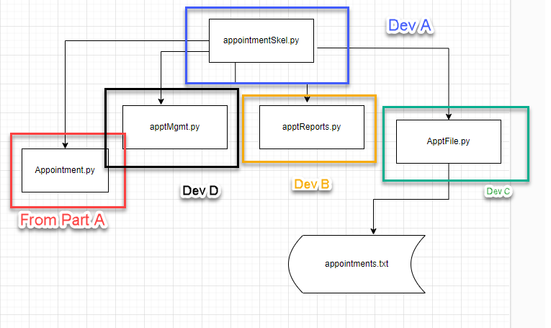

**A skeleton file folder structure with all the appropriate files can be downloaded as used as a starting point for the assignment. (see Skeleton.zip). Make sure you add your appointment class that you developed in Part 1 to this folder.**

**Starting Data File: see *appointments1.csv***.

Make sure that your application maintains the same comma-separated format established in this file.

## Peer Assessment

Please accurately use and complete the following table. Each member should assign a mark out of 10 to other group members.

|  |  |  |  |  |
| --- | --- | --- | --- | --- |
|  | Reviewer Member 1 Name | Reviewer Member 2 Name | Reviewer Member 3 Name | Tasks Description |
| Member 1 Name | -- | 9 | 10 | tasks completed |
| Member 2 Name | 10 | -- | 10 | tasks completed |
| Member 3 Name | 10 | 9 | -- | tasks completed |
| Average | 10 | 9 | 10 |  |

## Marking Criteria

## Rubric available on Brightspace